Exp.No:2
Determination and plotting of Electric field and Electric flux density in sphere full of charges with varying radius.
Aim:
To write program for electric field and electric flux density insphere using
SCILAB.

Softwarerequired:
- SCILABversion6.0.1

Program:
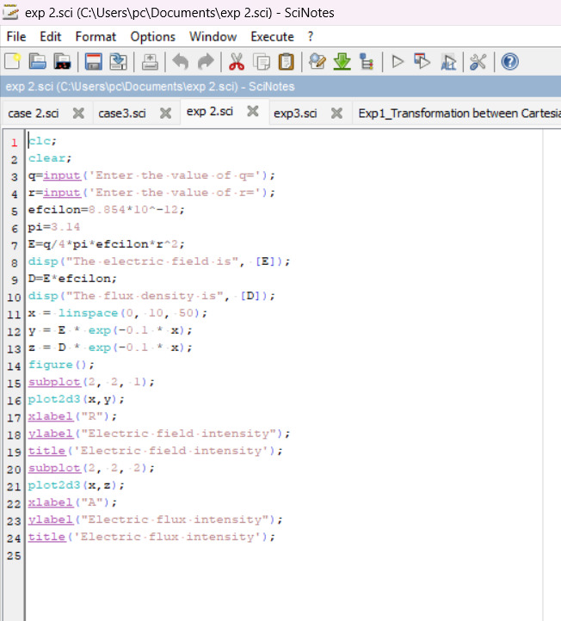

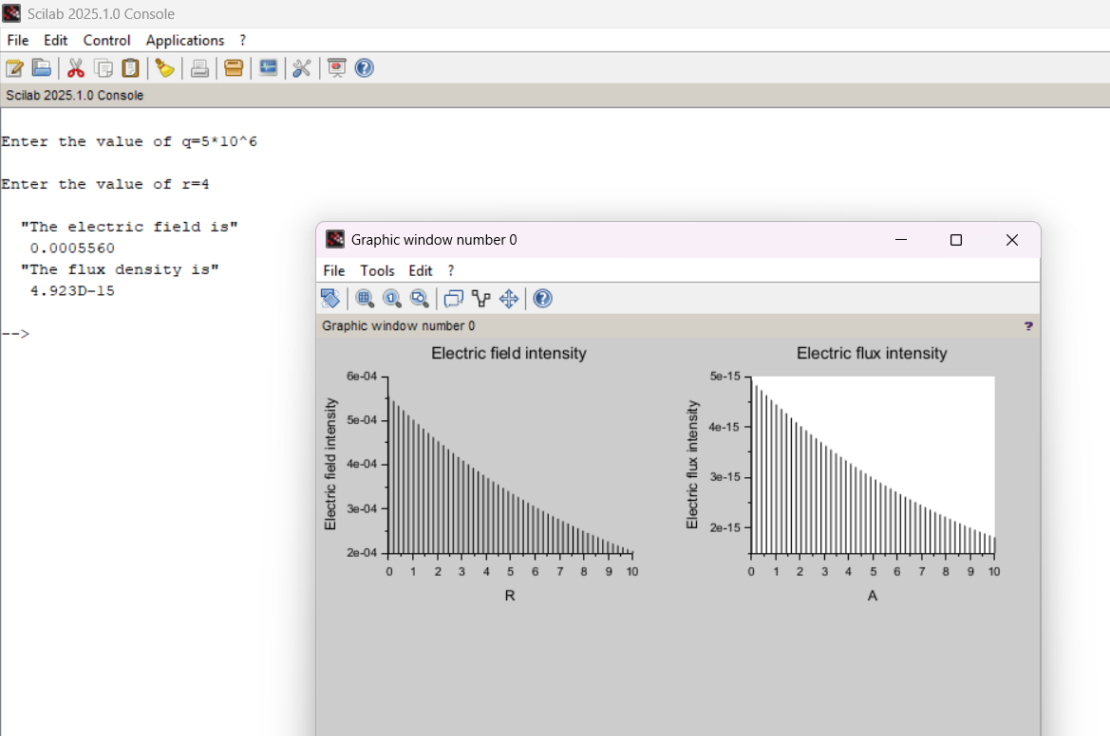

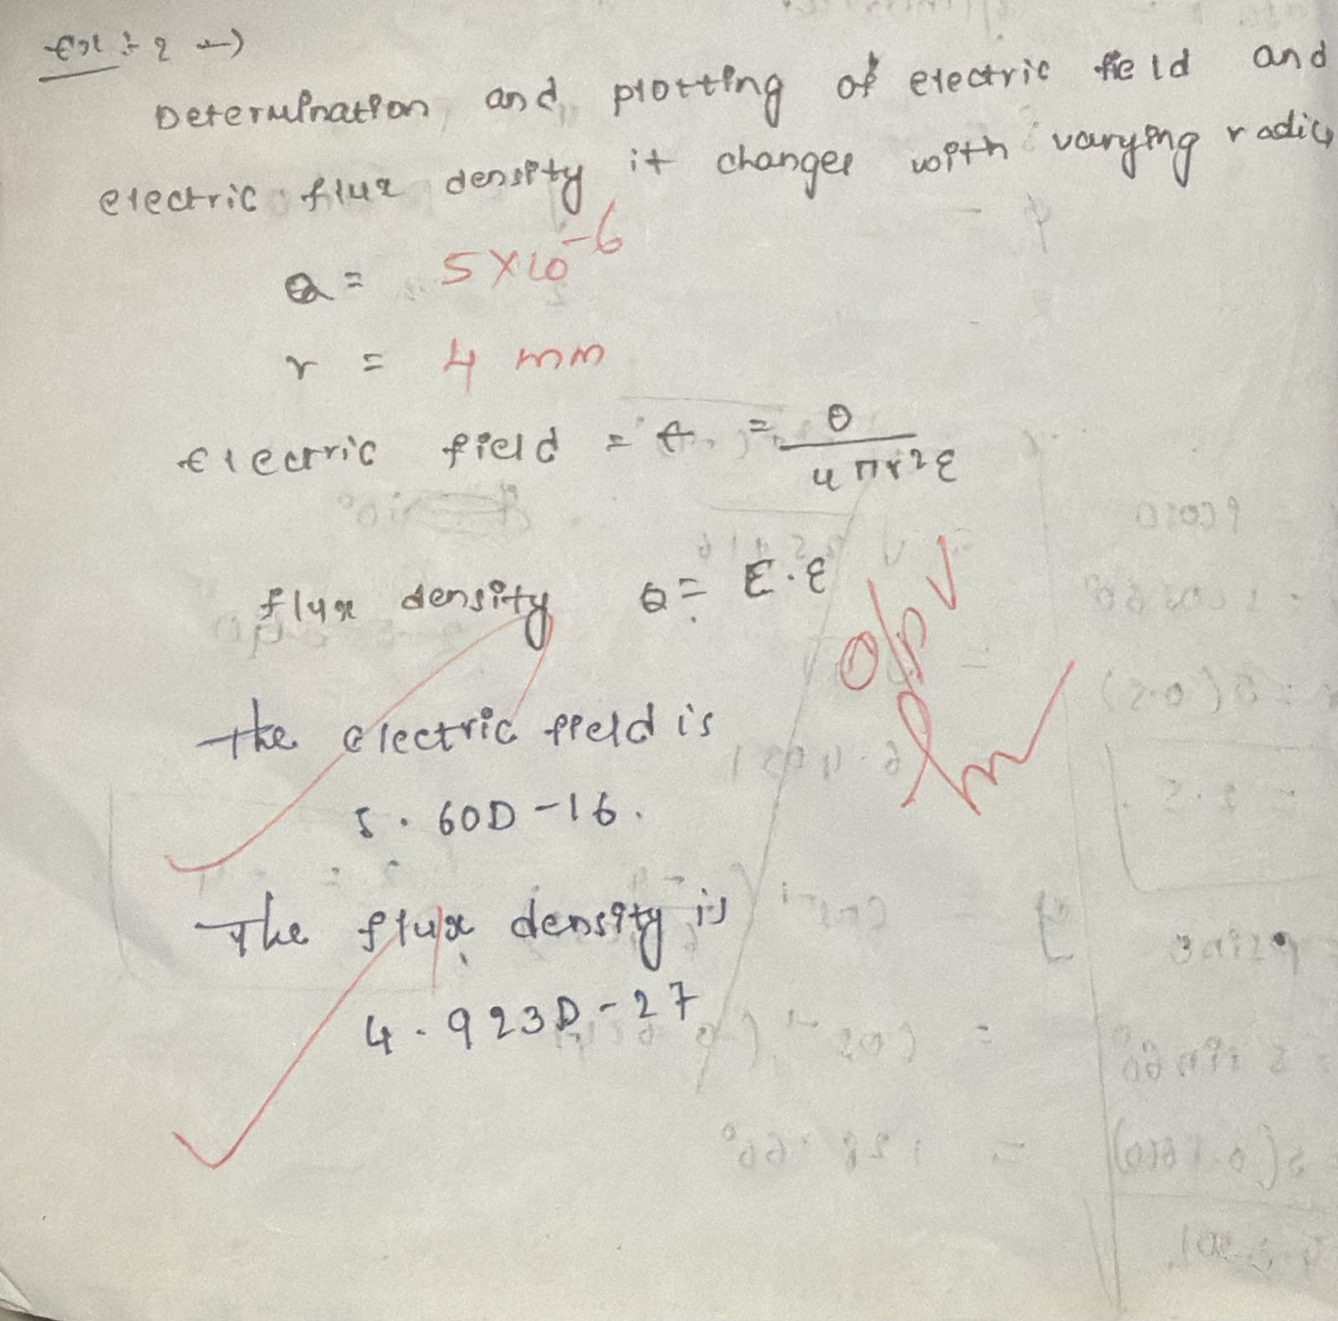
Result:
Thus the program was verified for electric field and electric flux density in sphere using SCILAB was successfully.

